 | 10.3.7 Editors - Compositor Editor - Sidebar - Group tab
Table of content
Group tab - Introduction 2
Properties Panel 3
Name 3
Description 3
Color Tag 3
Group Sockets Panel 4
Group Socket List 4
List 4
Name 4
New Item 4
Input 4
Output 4
Panel 4
Duplicate Item 4
Remove Item 4
Move Item Up/Down 5
Inputs 5
Outputs 5
Type 5
Socket Type Properties 5
Description 5
Default 5
Min 5
Max 5
Subtype 5
Hide Value 6

Group tab - Introduction
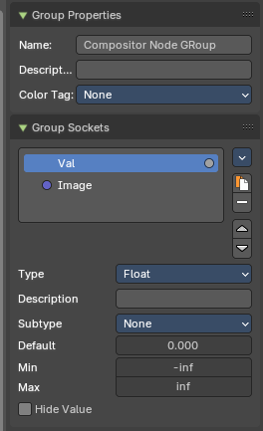
The Compositor sidebar Group tab at the right side contains options and settings for node groups and socket input and output properties.

Properties Panel

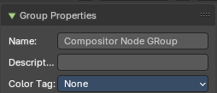
Name
Change the name of the current node group. Type in a new name and hit enter.

Description
Change the description of the current node group. Type in a new name and hit enter.

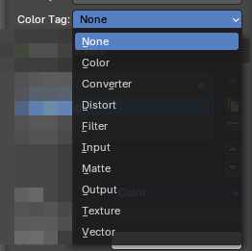
Color Tag
Changes the header color of the current node group.
Color Tag Types:
- Color
- Converter
- Distort
- Filter
- Input
- Matter
- Output
- Texture
- Vector

Group Sockets Panel
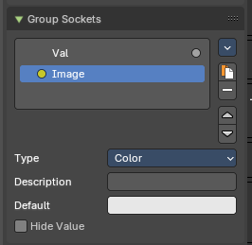
Manage the input and output properties of the Group Input and Output nodes.
More than one input and output slot can be useful when you want to modify compositor sockets in the node group in more than one way.

Group Socket List
List of available input and output sockets.
Note: The list can be sorted by dragging the items around.

List
The list of input and output sockets.

Name
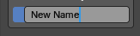
Change the name of the current selected input socket by double clicking on the socket in the list. Type in a new name and hit enter.

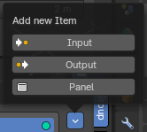
New Item
Adds a new input sockets to the list.

Input
Adds a new input sockets to the list.

Output
Adds a new output socket to the list.

Panel
Adds a new panel socket to the list.

Duplicate Item
Duplicates the active socket.

Remove Item
Removes the selected input socket from the list.

Move Item Up/Down
Moves the active item to the specified direction. You can move the active item up or down the list.
Note: You can also alternatively drag and drop the active item to re-order.

Inputs
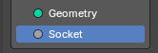
Inputs are characterized by the colored dot to the left. These are manifested in the Group Input node.

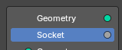
Outputs
Outputs are characterized by the colored dot to the right. These are manifested in the Group Output node.

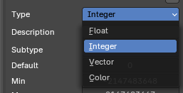
Type
What kind of node group input or output type it is. To know more about the properties of the socket types, refer to the next section.
- Vector
- Integer
- Float
- Color

Socket Type Properties

Description
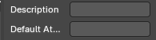
Add a tooltip to the socket description.

Default
The default value for the socket.

Min
The minimum value for the socket.
Note: This is only available for vector and float types.

Max
The maximum value for the socket.
Note: This is only available for vector and float types.

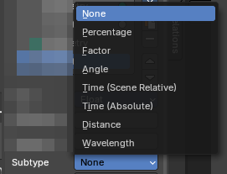
Subtype
Some node types have a subtype dropdown menu, such as the vector or float. The subtype menu allows you to define the socket type sliders and read-out.

Hide Value
Hide the input value even when the socket is not connected.

